**A project report on**

**Online Job portal**

**(Course Code: MCAE-)**

**Master in Computer Application**

**6th Semester**

**TO**

**Department of Computer Science**

**Your University**

**(A Central University)**

**,Address of college , Lucknow-22602**

**Supervisor Submitted By**

**Your Name Dr. Teacher kumar Roll no. 180908**

**Mrs. Teacher Name**

**TABLE OF CONTENTS**

* INTRODUCTION
* PROBLEM DEFINITION
* OBJECTIVE
* REQUIREMENT SPECIFICATION
* MODULE DISCRIPTION
* PROBLEM FORMULATION
* FEASIBILITY STUDY
* PROBLEM SPECIFICATION
* MANAGEMENT SYSTEM ARCHETECTURE DESIGN
* SOFTWARE DEVELOPMENT
* ER DIAGRAMS
* DATA FLOW DIAGRAM
* PROJECT PLANING AND SCHEDULING
* FUTURE SCOPE OF THE PROJECT
* REFERENCE

**INTRODUCTION**

Online Job Portal is a part of online information sharing about job. see latest job and applying of website or services over electronic management systems such as the Internet and other computer networks. Thus if we have own a business and we want employee then need to upload job profile online to attract potential employees.

The online job portal system gives the platform to search job online and easily apply

and join to company by giving the interview and all formalities facility to apply for job online.

With an online applying for job at any time it provide facility 24 *7. Thus it is a simple, fast and convenient of finding job management system giving an edge over the competition at an affordable price.

Internet has seen a tremendous growth in terms of coverage and awareness.

So giving the student an online presence has become very crucial and important.

With [Job Portal Management system], we can upload our detail online and the companies can easily find and contact with persons in a simple mouse click. Also with a job online we can easily get the job profile detail, prepare for that and improve the people according to job need. We can receive feedback of this app through e-mails/ fax or directly view on internet.

**PROBLEM DEFINITION**

At present there are many Job Portal management systems that maintain their day to day increase knowledge. These have a number of students as a result they need to track of all these questions requirements. At this point JOB PORTAL MANAGEMENT SYSTEM will play an important role in helping the admin to perform all these operation on a single click. This project will handle all the necessary data as well as every minute details of the campus and properly.

**Purpose**

The purpose of this document is to specify requirements and to give guidelines for the development of above said project. In particular it gives guidelines on how to prepare the above said project. The old management system was suffering from a series of the drawbacks. Since whole management system was to be maintained with hands the process of keeping, maintaining and retrieving the information was very tedious and lengthy. The records were never used to be in a management systematic order as a result there used to be lot of difficulties in associating any particular transaction with a particular context. If any information was to be found it was required to go through different registers, documents there would never exist anything like report generation. There would be unnecessary consumption of time while entering records and retrieving the records. One more problem was that it was very difficult to find errors while entering records as a result if one record was entered then it was difficult to update these records.

**Scope**

As this is generic software it can be used by a wide variety of quiz to automate the process of manually maintaining the records related to the subject of maintaining the entries and updating these records that too in a single click.

**OBJECTIVE**

Today’s world is computer world because most of work is doing with the help of computer. Dependency on computer is behind the few reasons. We cannot easily manage to store large number of data or information single handle. If we will be need some information or data in urgency then we cannot manage in manually these works are very difficult if we cannot use computer.

As the generic software it can be used by a wide verity of buss to automate the process of manually maintaining records related to the subject of maintain the records of each personnel in bus.

This software is basically updating the manual work of management systems. So that organization can manage their record in efficient and organize them.

* The main objective of the project is to develop software that facilitates the data storage, data maintenance and its retrieval for the restaurant in an igneous way.
* To store the records of the students, the staff that has the privileges to access, modify and delete any record and finally the service, restaurants provides to its staff and students.
* To save manpower.
* It will speed the processing of data and transaction.
* It will provide best security features such as provisions of passwords
* To develop a user friendly management system that requires minimal user training.

**Management system Objective:-**

Today’s world is computer world because most of work is doing with the help of computer. Dependency on computer is behind the few reasons. We cannot easily manage to store large number of data or information single handle. If we will be need some information or data in urgency then we cannot manage in manually these works are very difficult if we cannot use computer.

**Management system Context:-**

This section clearly depicts the environment and boundaries of JOB PORTAL MANAGEMENT SYSTEM and the entities with which it interacts. It helps us see how the management system fits into the existing scheme of things. What the management system will do by itself.

**Functional Requirement:-**

This Software must request Username and Password for access to data, only after authentication will allow access to the management system. The Software must allow input of products data from administrator and secured access.

**Non-Functional Requirement:-**

In this Software Input error will be returned in red with appropriate message box. Management system should automatically update after every transaction.

**REQUIREMENT’S SEPECIFICATIONS**

**HARDWARE AND SOFTWARE SPECIFICATION**

1. **Minimum Hardware Requirements**

* Pentium IV Processor
* 512 MB RAM
* 40 GB HDD
* Color Monitor
* Keyboard, Mouse

1. **Software Requirements:-**

* Python 3 (Any version)
* Any text editor (PyCharm , Notepad++, etc.)

**MODULE DESCRIPTION**

* **Login:**

The ONLINE job portal first activates the login page. Here the user enters USER NAME AND PASSWORD and the management system starts authentication process in which the USER NAME AND PASSWORD is matched with the existing USER NAME AND PASSWORD in the database. If the password matches then it is allowed to the main page else it warns the user for invalid USER NAME AND PASSWORD.

After the successful authentication the management system activated menus. The activity log also prepared for failure and security There are two types of users using this software i.e., admin, student, faculties and staff.

* **RECRUITER:**

This module has authority configuration that admin and recruiter can access this module. Here admin performs allow to recruiter to adding new job’s details. And if admin allow to recruiter and admin can also details of recruiter and have authority to delete recruiter also.

* **USER:**

This module has software configuration that admin and users can access this module. Here admin performs certain operations like adding new user details. In this admin assigns tasks to employee according to their capabilities.

* **Job:**

Job are handled in this module by the admin and recruiter when user apply for job.

**PROBLEM FORMULATION**

**Introduction:-**

Problem introduction or problem starting is the starting point of the software development activity. The objective of this statement is to answer: Exactly *what must the management system do*? The software project is initiated by the client’s need. In the beginning, these needs are on the minds of various people in the client’s organization. The analyst has to identify the requirements by talking to the people and understanding to their needs. It goes without saying that an accurate and through understanding of software requirement are essentials to the success of software development effort. All further development like management system analysis. Management system design and coding will depends on how accurate and well understood the requirements are poorly analyzed and specified software will disappoint the user and will bring brief to the developer. No matter how well designed and well appearances are often deceiving. Chances of misinterpretation are very high, ambiguity is probable and communication gap between student and developer is bound to bring confusions. Requirements understanding begin with a clear and concise heading stating in sentence the task to be performed. Then requirements are describe in a technical manner precise statement.

**Feasibility study:-**

All projects are feasible given unlimited resources and infinite time! Unfortunately, the development of computer based management system is more likely to be plagued by a scarcity of resources. It is both necessary and prudent to evaluate the feasibility of the project at the earliest possible time. Months or years of effort, Money loss and untold professional embarrassment can be averted I few better understand the project at its study time.

This type of study determines if an application can and should be developed. Once it has been determining that, application is feasible. After that analyst can go ahead and prepares the project specification, which finalizes project requirements. Feasibility studies are undertaken within tight time constraints.

Technical Feasibility

Operational Feasibility

Economic Feasibility

Legal Feasibility

**1.Technical Feasibility:-**

As we know the technical feasibility is concerned with specifying equipment and software that will successfully satisfy the user requirement. The technical needs of the management system may vary considerably, but might include:

* Response time under certain condition is minimal.

Ability to process a certain volume of transaction at a particular speed.

Facility to communicate data to distinct location.

In examining the technical feasibility, configuration of the management system is given more importance than the actual make of hardware. The configuration should give the complete picture about the management system’s requirements- how many workstations are required, how these units are interconnected so that they could operate and communicate smoothly.

**2.Operational Feasibility:-**

Proposed projects are beneficial only if they can be turned into information management system that will meet the financial management requirements of the business/organization. This test of feasibility asks if the management system will work when it developed and installed. Are there major barriers to implementation?

Some of the important questions that are useful to test the operational feasibility of a project are given below:

* + Is there sufficient support for the project from the implementation? From user? If the present management system is well liked and used to the extent that persons will not be able to see reasons for change, there may be resistance.
  + Are current business methods acceptable to the user? If they are not, user may welcome a change that will bring about a more operational and useful management system.
  + Have the user been involved in the planning and development of the Project? If they are involved at the earliest stage of project development, the chances of resistance can be possibly reduced.
  + Will the proposed management system cause harm? Will it produce poorer result in any case or area?
  + Will the performance of staff member fall down after implementation? Issue that
  + Appears to be quite minor at the early stage can grow into major problem after Implementation.

**3. Economical Feasibility:-**

Economic analysis is the most frequently used technique for evaluating the effectiveness of the proposed management system. More commonly known as cost/benefits analysis, the procedure is to determine the benefits and savings that are expected from the purposed management system and compared with costs.

If benefits outweigh cost, a decision is taken to design and implement the management system. Otherwise, further justification or alternative of the proposed management system will have to be made if it has a chance of being approved. This is an ongoing effort that improves in accuracy at each phase of the management system life cycle. The analysis part also clears the doubt of economic problems which could be possible in developing the management system. As already mentioned that the company has to just pay the developed software cost and not other investment is needed at the time of implementation of the new management system as the preliminary requirements already exist in the company.

**4.Legal Feasibility:-**

In the legal feasibility is necessary to check that the software we are going to develop is legally correct which means that the ideas which we have taken for the proposed management system will be legally implemented or not so, it is also an important step in feasibility study.

# Class Diagram of the Project

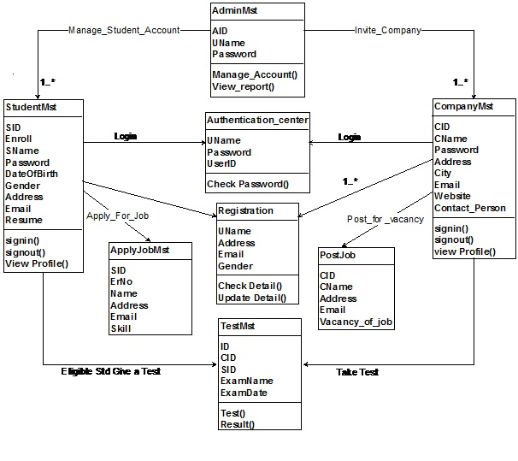

# Activity Diagram of the Project

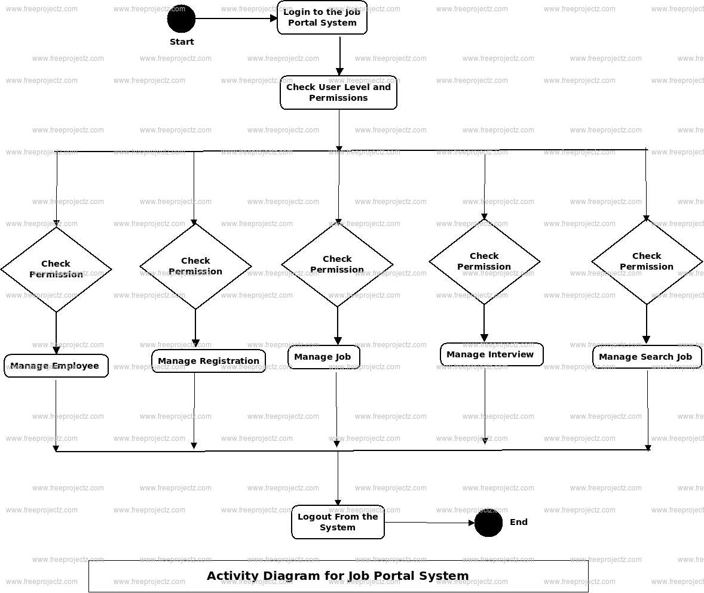

# Communication Diagram of the Project

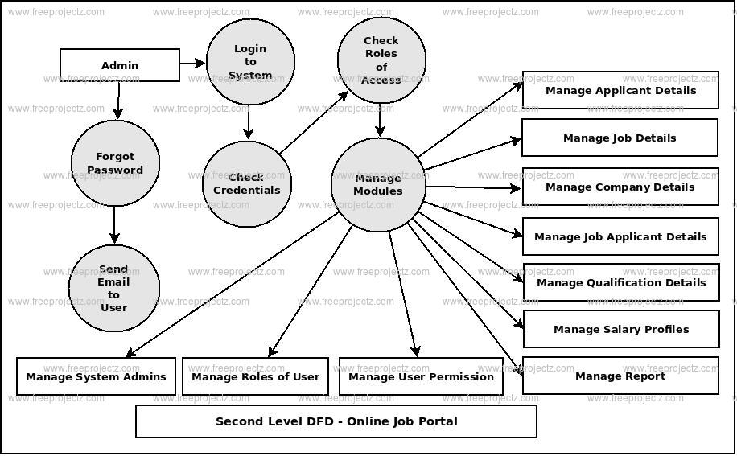

**PROBLEM SPECIFICATION**

The definition of our problem lies in manual management system and a fully automated management system.

**1 Manual Management system:-**

The management system is very time consuming and lazy. This management system is more prone to error and sometimes the approach to various problems is unstructured.

**2 Technical Management system:-**

With the advent of latest technology if we do not update our management system then our business result in losses gradually with time. The technical management system contains the tools of latest trend i.e. computers, printers, FAX, Internet etc the management system with the technology are very fast, accurate, user friendly and reliable.

**3. The Proposed Management system:-**

The proposed management system helps them in many ways. It helps them do billing very easily. Account maintenance also becomes easier. They can keep track of their sales, stocks of the supplements and account details of their students regarding their packages and many more. The software is provided with all the master entries to enter any new product, or student or trainer to add or modify and delete.

**MANAGEMENT SYSTEM ARCHETECTURE DESIGN**

**1 DEFINING A MANAGEMENT SYSTEM:-**

Collection of component, which are interconnected, and work together to realize some objective, from a management system. There are three components in every management system, namely input, processing and output

Processing

Input Output

**MANAGEMENT SYSTEM DEVELOPMENT LIFE CYCLE:-**

The **Management system development life cycle (SDLC)**, or **Software development process** in [management systems engineering](http://en.wikipedia.org/wiki/Systems_engineering), [information management systems](http://en.wikipedia.org/wiki/Information_systems) and [software engineering](http://en.wikipedia.org/wiki/Software_engineering), is a process of creating or altering information management systems, and the models and [methodologies](http://en.wikipedia.org/wiki/Methodologies) that people use to develop these management systems. In software engineering, the SDLC concept underpins many kinds of [software development methodologies](http://en.wikipedia.org/wiki/Software_development_methodologies). These methodologies form the framework for planning and controlling the creation of an information management system the [software development process](http://en.wikipedia.org/wiki/Software_development_process).

Broadly, following are the different activities to be considered while defining the management system development life cycle for the said project:

Problem Definition

Management system Analysis

Study of existing management system

Drawback of the existing management system

Proposed management system

Management system Requirement study

Data flow analysis

Feasibility study

Management system design

Input Design (Database & Forms)

Updating

Query /Report design

Administration

Testing

Implementation Maintenance

**1.2 MANAGEMENT SYSTEM ANALYSIS:-**

**Management systems analysis** is the study of sets of [interacting](http://en.wikipedia.org/wiki/Interaction) [entities](http://en.wikipedia.org/wiki/Entity), including computer management systems analysis. This field is closely related to [requirements analysis](http://en.wikipedia.org/wiki/Requirement_analysis) or [operations research](http://en.wikipedia.org/wiki/Operations_research). It is also "an explicit formal inquiry carried out to help someone (referred to as the decision maker) identify a better course of action and make a better decision than he might otherwise have made.

Management system development can generally be thought of having two major components: management systems analysis and management systems design. In Management system Analysis more emphasis is given to understanding the details of an existing management system or a proposed one and then deciding whether the proposed management system is desirable or not and whether the existing management system needs improvements. Thus, management system analysis is the process of investigating a management system, identifying problems, and using the information to recommend improvement to the management system.

**1.3 MANAGEMENT SYSTEM DESIGN:-**

Management systems design is the process of defining the architecture, components, modules, interfaces, and [data](http://en.wikipedia.org/wiki/Data) for a [management system](http://en.wikipedia.org/wiki/System) to satisfy specified [requirements](http://en.wikipedia.org/wiki/Requirement). One could see it as the application of [management systems theory](http://en.wikipedia.org/wiki/Systems_theory) to [product development](http://en.wikipedia.org/wiki/Product_development). There is some overlap with the disciplines of [management systems analysis](http://en.wikipedia.org/wiki/Systems_analysis), [management systems architecture](http://en.wikipedia.org/wiki/Systems_architecture) and [management systems engineering](http://en.wikipedia.org/wiki/Systems_engineering). If the broader topic of [product development](http://en.wikipedia.org/wiki/Product_development) "blends the perspective of marketing, design, and manufacturing into a single approach to product development," then design is the act of taking the marketing information and creating the design of the product to be manufactured. Management systems design is therefore the process of defining and developing [management systems](http://en.wikipedia.org/wiki/System) to satisfy specified [requirements](http://en.wikipedia.org/wiki/Requirement) of the user. Until the 1990s management systems design had a crucial and respected role in the [data processing](http://en.wikipedia.org/wiki/Data_processing) industry. In the 1990s [standardization](http://en.wikipedia.org/wiki/Standardization) of hardware and software resulted in the ability to build [modular](http://en.wikipedia.org/wiki/Modularity_(programming)) management systems. The increasing importance of software running on generic platforms has enhanced the discipline of [software engineering](http://en.wikipedia.org/wiki/Software_engineering).

[Object-oriented analysis and design](http://en.wikipedia.org/wiki/Object-oriented_analysis_and_design) methods are becoming the most widely used methods for computer management systems design. The [UML](http://en.wikipedia.org/wiki/Unified_Modeling_Language) has become the standard language in object-oriented analysis and design. It is widely used for modeling software management systems and is increasingly used for high designing non-software management systems and organizations

**ENTITY RELATION DIAGRAMS:-**

The Entity Relation Model or Entity Relation Diagram (ERD) is a data model or diagram for high-level description of conceptual data model, and it provides a graphical notation for representing such data models in the form of entity relationship diagrams. Such models are typically used in the first stage of Management information management system design; they are used for example, to describe information needs and/ or the type of information that is to be stored in the Database during the requirement analysis. The data modeling technique, however, can be used to describe any ontology ( i.e an overview and classification of used term and their relationships) for a certain universe of discourse (i.e area of interest ).

In the case of design a Management Information Management system that is based on a database, the conceptual data model is, a later stage( usually called logical design), mapped to a logical data model such as, relational data model; this is turn in mapped to a physical model during physical design. Note that sometimes, both of the phases are referred a “physical design”. There are number of convention for entity-relation diagrams (ERDs). The classical notation is describe in the remainder of this article, and mainly related to the conceptual modeling. There is a range of notation more typically employed in physical and logical database design.

**DATA FLOW DIAGRAM**

The data flow diagram shows the flow of data within any management system. It is an important tool for designing phase of software engineering. Larry Constantine first developed it. It represents graphical view of flow of data. It’s also known as BUBBLE CHART. The purpose of DFD is major transformation that will become in management system design symbols used in DFD.

In the DFD, four symbols are used and they are as follows.

1. A square defines a source (originator) or destination of management system data.
2. An arrow identifies data flow-data in motion. It is 2a pipeline through which information flows.
3. A circle or a “bubble “(Some people use an oval bubble) represents a process that transfers informing data flows into outgoing data flows.
4. An open rectangle is a data store-data at rest, or a temporary

Repository of data.

**Context Level Data Flow Diagram:-**

This level shows the overall context of the management system and its operating environment and shows the whole management system as just one process. Online book store is shown as one process in the context diagram; which is also known as zero level DFD, shown below. The context diagram plays important role in understanding the management system and determining the boundaries. The main process can be broken into sub-processes and management system can be studied with more detail; this is where 1st level DFD comes into play.

Admin

Job Portal

Recruiter

Customer/user

View Job

Add Job

signup

Manage Recruiter

Comfirm Job Detail

Delete Job

Add Job

See Feedback

Recruiter Detail

Manage User

Manage user

See applyed Status

Apply Job

See Job

Signup

Delete Job

Manage Job Detail

**Zero Level Data Flow Diagram**

**First Level DFD:-**

This level (level 1) shows all processes at the first level of numbering, data stores, external entities and the data flows between them. The purpose of this level is to show the major high-level processes of the management system and their interrelation. A process model will have one, and only one, level-1 diagram. A level-1 diagram must be balanced with its parent context level diagram, i.e. there must be the same external entities and the same data flows, these can be broken down to more detail in the level 1.

One level data flow diagram

**Project Planning & Project Scheduling**

**PERT CHART**

A project plan needs to be created to ensure the timely completion of the project. As part of project analysis, we break the project down to a number of stages and use a Gantt chart and PERT chart to describe specific tasks and status.

The Work Breakdown Structure of our proposed management system “E-Commerce” is shown below:

|  |  |  |  |  |  |  |  |  |
| --- | --- | --- | --- | --- | --- | --- | --- | --- |
| ID | Task Name | Duration | Start | Finish | Predecessors | | | Resource Names |
| 1 | **Project Initiation** | 2 days | Sat 6/02/2021 | Mon  08/02/2021 |  | | |  |
| 2 | Draft Project Plan | 2 days | Tue 09/02/2021 | Thu  11/02/2021 |  | | |  |
| 3 | **Analysis Phase** | 7 days | Fri 12/02/2021 | Fri 19/02/2021 |  | | |  |
| 4 | Plan User Interviews | 2 days | Sat 20/02/2021 | Mon 22/02/2021 |  | | |  |
| 5 | Schedule users Interviews | 3 days | Tue 23/02/2021 | Fir 26/06/2021 |  | | |  |
| 6 | Conducting users Interviews | 2 days | Mon 1/03/2021 | Wed 04/03/2021 |  | | |  |
| 7 | **Management system Design** | 20 days | Fri 05/03/2021 | Sat 27/03/2021 | 6 | | |  |
| 8 | Modules Design | 10 days | Wed 31/8/18 | Sat 10/04/2021 | |  |  | |
| 9 | Data Structure Design | 3 days | Mon 12/04/2021 | Thu 15/04/2021 | | 8 |  | |
| 10 | User Interface Design | 3 days | Fri 16/04/2021 | Mon 19/04/2021 | |  |  | |
| 11 | Coding Phase | 36 days | Tue 20/04/2021 | Thu 25/05/2021 | |  |  | |
| 12 | **Testing Phase** | 9 days | Wed 26/05/2021 | Fri  04/06/2021 | |  |  | |
| 13 | Integration Testing | 5 days | Sat 05/06/2021 | Thu 10/06/2021 | |  |  | |
| 14 | Management system Level Testing | 4 days | Fri 11/06/2021 | Thu 15/06/2021 | |  |  | |
| 15 | Implementation | 4 days | Fri 16/06/2021 | Sun 20/06/2021 | |  |  | |
| 16 | Post-Implementation Review | 2 days | Mon 21/06/2021 | Wed 23/06/2021 | |  |  | |

**DATABASE TABLES**

1. **Admin and User Login Table**

**FUTURE SCOPE OF THE PROJECT**

The proposed management system helps them in many ways. It helps them do billing very easily. Account maintenance also becomes easier. They can keep track of their purchases, sales, stocks and account details. The website is provided with all the master entries to enter any new product, or supplier, or to add or modify and delete.

As this is generic software it can be used by a wide variety of outlets (Retailers and Wholesalers) to automate the process of manually maintaining the records related to the subject of maintaining the stock and cash flows.

In future it can be modify, so that it can be done online. In order to meet these facility this is the major change which can be done in future regarding this project.

**References**

Reference Books

Head First PYTHON with django & SQLITE- By Lynn Beighley & Michael Morrison

The Complete Reference- PYTHON- with django (Guido van rossun)

Reference websites

* + [www.youtube.com](http://www.scribed.com)
  + [www.w3schools.com](http://www.w3schools.com)
  + [www.javatpoints.edu](http://www.javatpoints.edu)